Title: Exploratory Data Analysis of a Healthcare Dataset
Course Code: CSC 481- Special Topics in computer science
Name: Nathaniel Etim Effiom
Track No: 22/132009
Level: 400

Overview:
Healthcare data analysis is essential for understanding patterns related to patient demographics, disease prevalence, and healthcare service utilization. By analyzing healthcare datasets, meaningful insights can be extracted to support decision-making and improve health outcomes.
This project focuses on conducting an exploratory data analysis (EDA) on a healthcare dataset using data visualization techniques to uncover trends and patterns within the data.
Healthcare datasets often contain large volumes of information that are difficult to interpret without proper analysis. Without visualization and exploration, important insights related to patient age distribution and common medical conditions may remain hidden.

Dataset Used:
The dataset used in this analysis contains healthcare records of patients, including demographic and clinical information. It consists of approximately 55,500 records with 15 attributes such as age, gender, medical condition, admission type, and billing amount.
The analysis was conducted using Python in a Jupyter Notebook environment. The dataset was loaded and inspected to understand its structure and contents. Exploratory Data Analysis (EDA) techniques were applied, and data visualization was performed using Matplotlib and Seaborn libraries.
Three types of visualizations were used in this study: a histogram, a bar chart, and a pie chart.

Data Analysis and Visualization
Age Distribution of Patients (Histogram)
A histogram was used to visualize the distribution of patient ages in the dataset. The visualization shows that most patients fall within the adult and elderly age groups, indicating higher healthcare utilization among older populations.
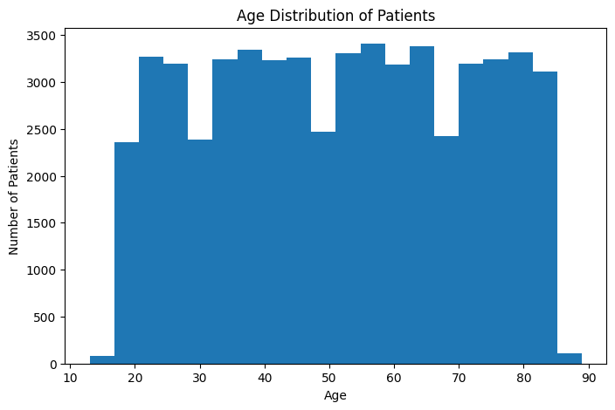

Frequency of Medical Conditions (Bar Chart)
A bar chart was used to represent the frequency of different medical conditions recorded in the dataset. The chart reveals that certain medical conditions occur more frequently than others, suggesting that some chronic illnesses are more prevalent among the patient population.
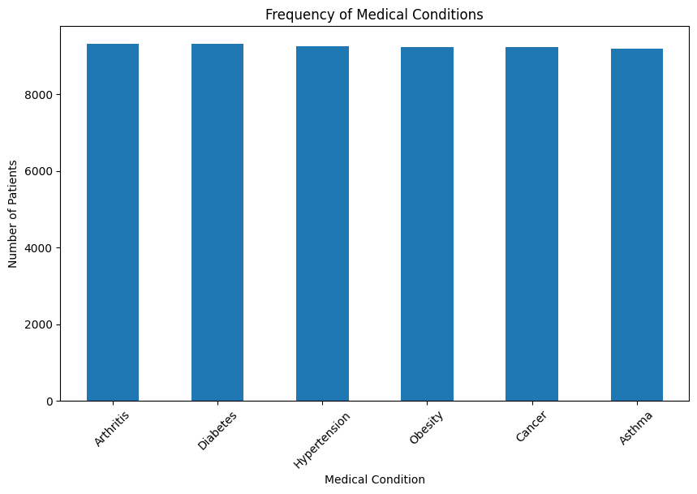

Distribution of Common Medical Conditions (Pie Chart)
A pie chart was used to show the proportion of the five most common medical conditions.
Explanation:
The pie chart indicates that a small number of medical conditions account for a large percentage of hospital cases, highlighting the dominance of specific health conditions within the dataset.
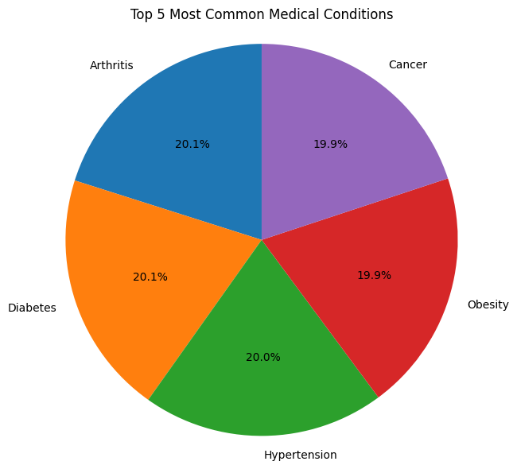

Findings
From the analysis and visualizations:
- The majority of patients are within middle-aged and elderly groups
- Some medical conditions are significantly more common than others
- A few dominant conditions contribute to most hospital visits
These findings emphasize the importance of focusing healthcare resources on prevalent conditions.
Conclusion
This project successfully analysed a healthcare dataset using exploratory data analysis techniques. Through the use of a histogram, bar chart, and pie chart, meaningful insights were obtained regarding patient age distribution and common medical conditions. The study demonstrates how data visualization can simplify complex healthcare data and support better understanding.

References
- Dataset Set used - https://www.kaggle.com/datasets/prasad22/healthcare-dataset

